Operations related to the annual assessment in IS Study (student)

1) Once logged in to the Student Information System (www.is.cuni.cz/studium), click the icon
“Individual study plan for PhD students”.
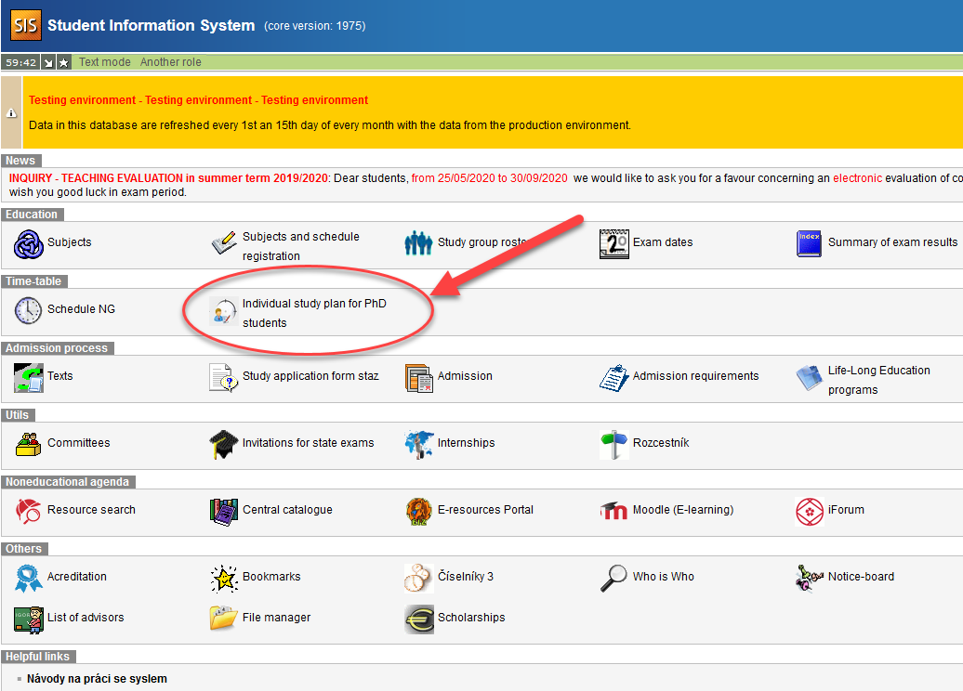

2) Click the blue icon on the left
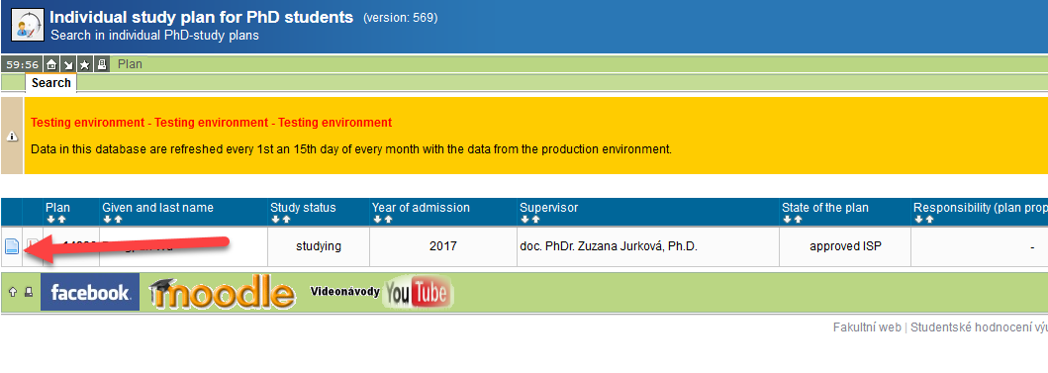

3) Use the link “Annual assessment of fulfilling the ISP” in the plan detail (1.) to open the detail of the annual assessment, and create the assessment form for the given academic year (2.).

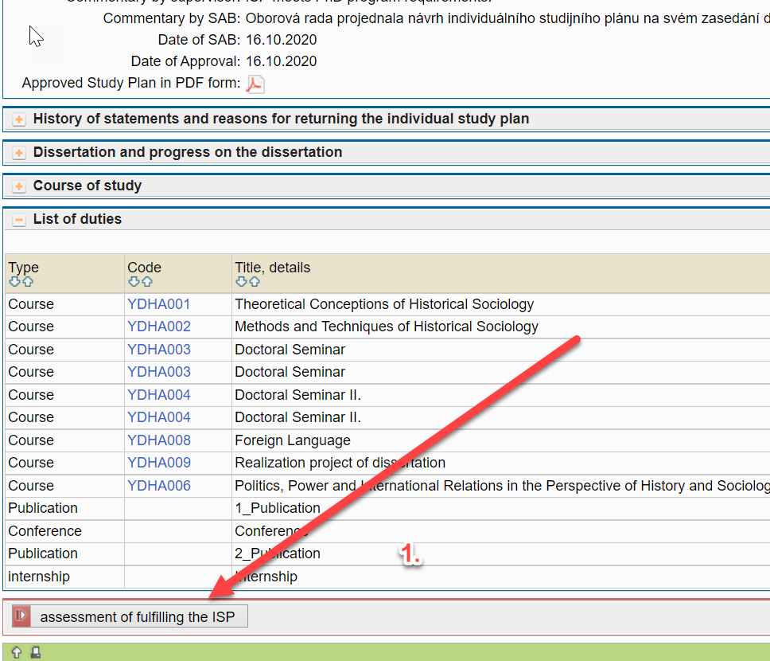

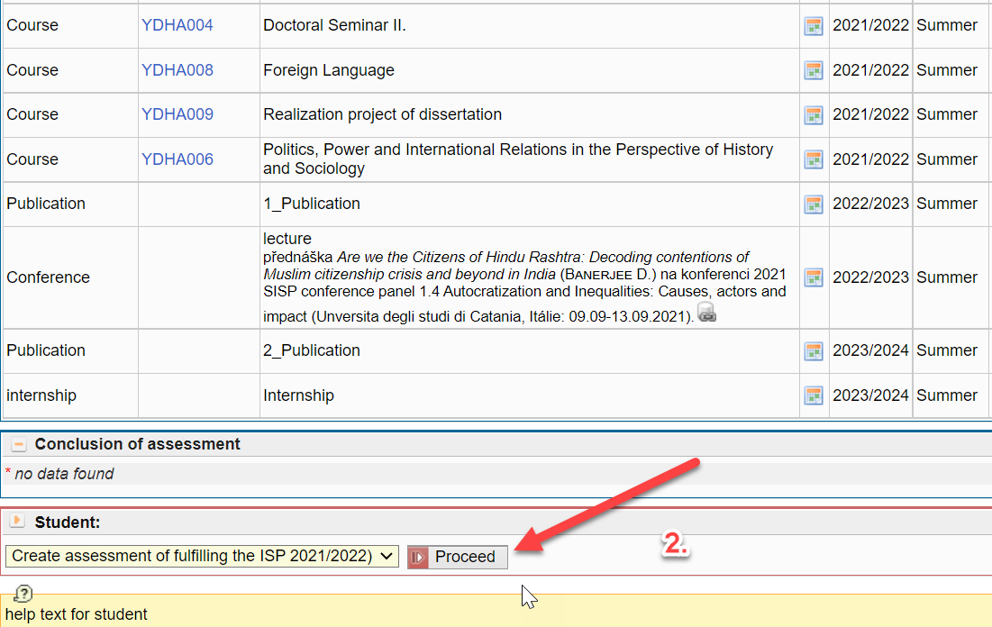
3) Click the list of duty
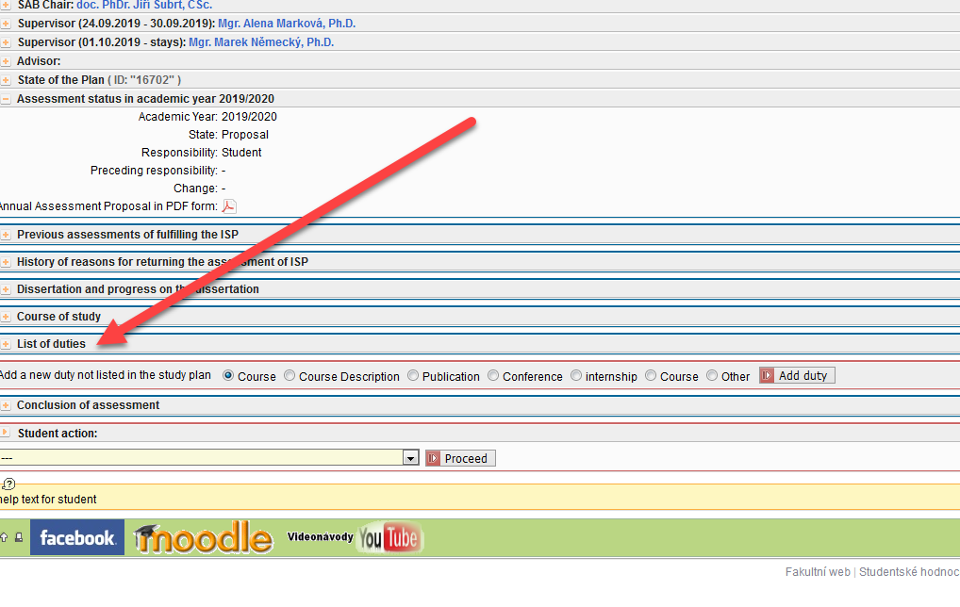
4) The next operations are possible in the annual assessment to mark duties that are enrolled in as complete / incomplete, and add verbal comments.
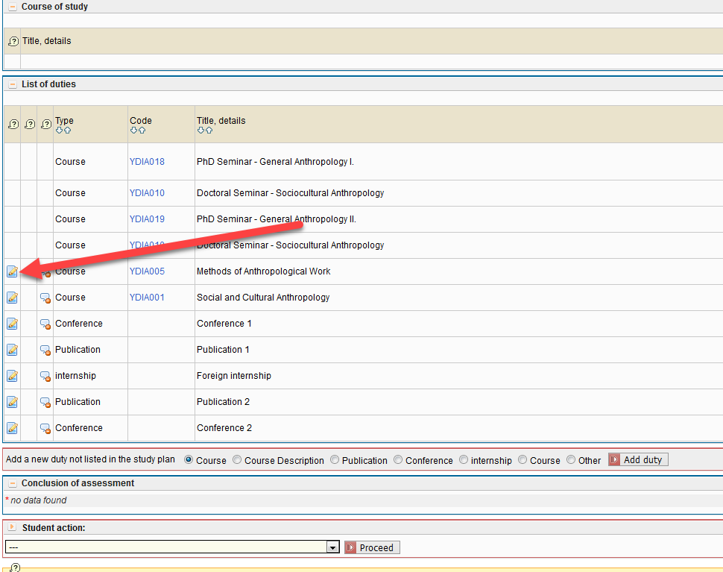

5) The annual assessment to mark duties that are enrolled in as complete / incomplete, and add verbal comments.

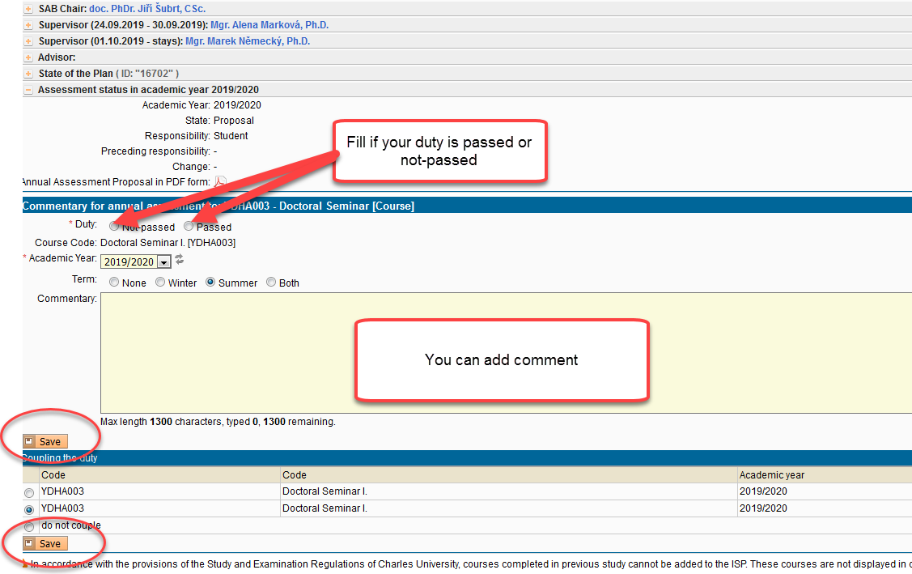

6) The annual assessment to mark duties publication and conferences that are enrolled in as complete / incomplete, and add verbal comments. A NECESSARY REQUIREMENT FOR PAIRING PUBLICATIONS AND CONFERENCES IS THEIR ASSIGNMENT IN THE SYSTEM OBD.
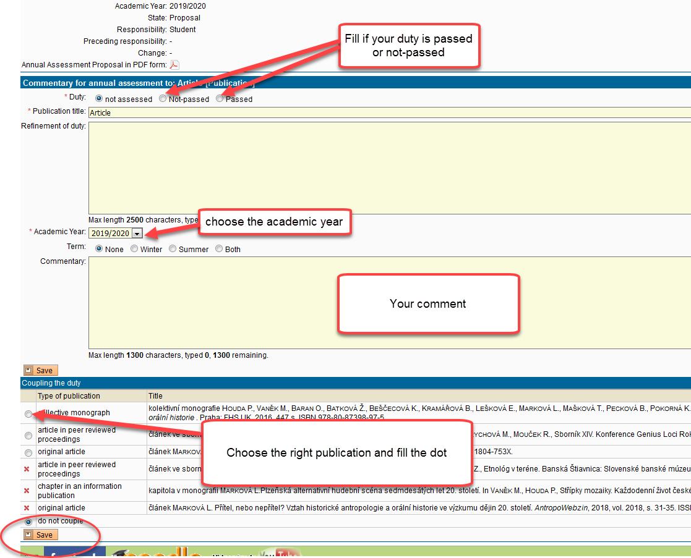

7) We are slowly finishing…
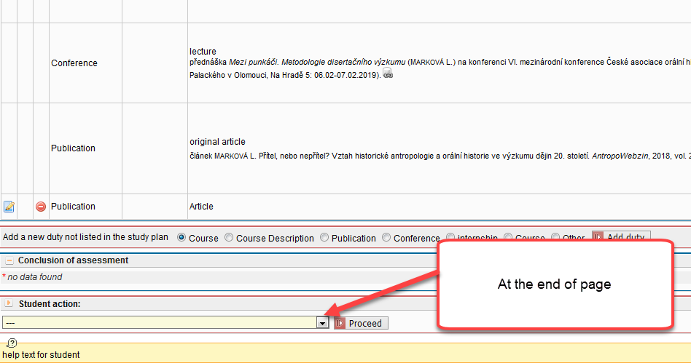

8) Fields marked with an asterisk are required.
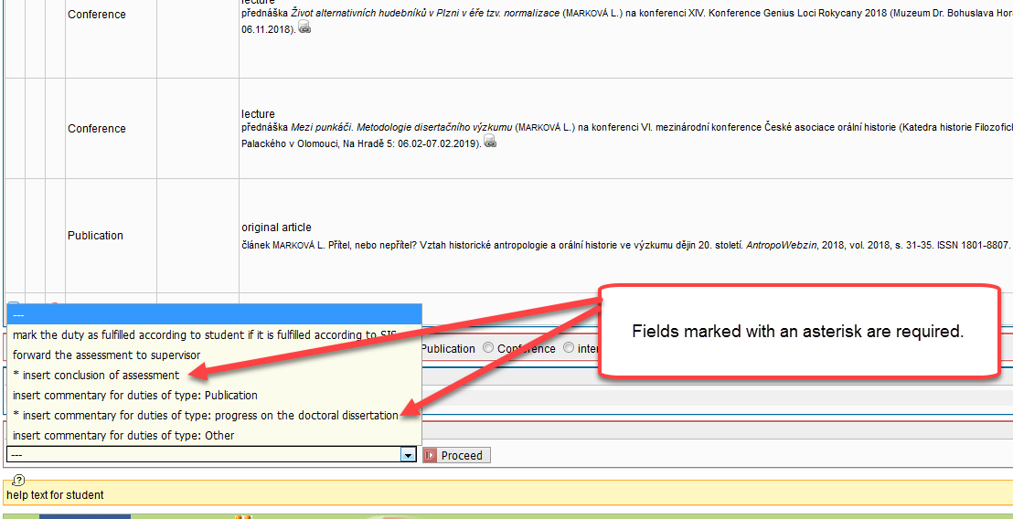

9) Lastly, leave the item to fill "insert conclusion of assessment".
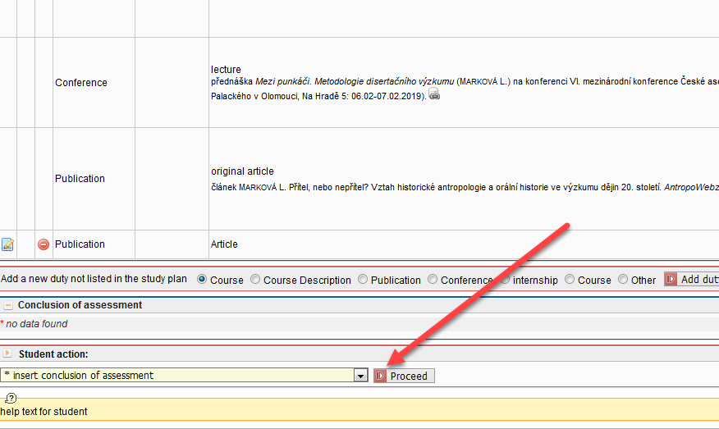

10) Insert conclusion of assessment.
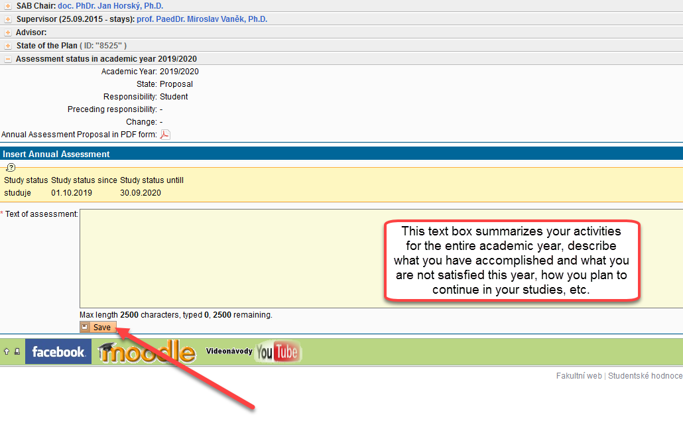
11) The last step is to forward assessment to supervisor. Once the proposal of the assessment is submitted to the supervisor, the student cannot further edit the annual assessment. If the supervisor returns the annual assessment to the student for changes or completion, the responsibility goes back to the student, and the relevant items can be edited again.

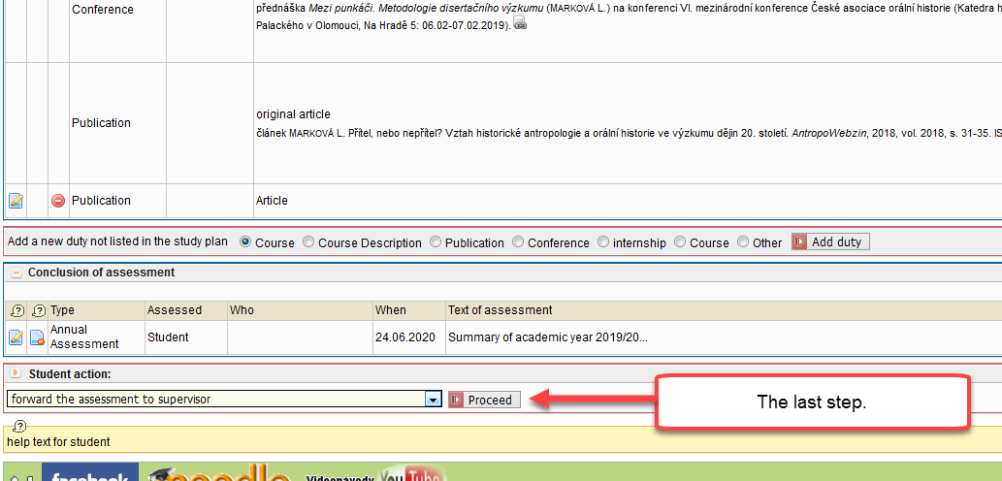

12) Finished!
