Instructions for applying for a doctoral scholarship
1. AFTER LOGGING INTO SIS – SELECT THE "FEES AND PETTITIONS" MODULE
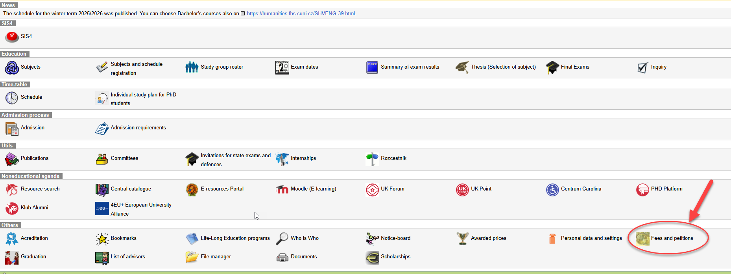

2. SELECT "NEW REQUEST" FROM THE MENU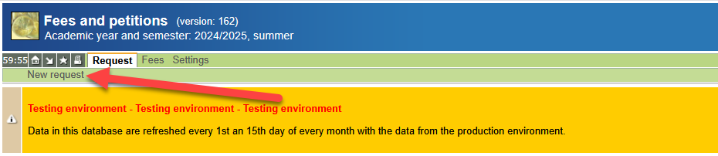

3. SELECT THE APPLICATION FOR A DOCTORAL SCHOLARSHIP
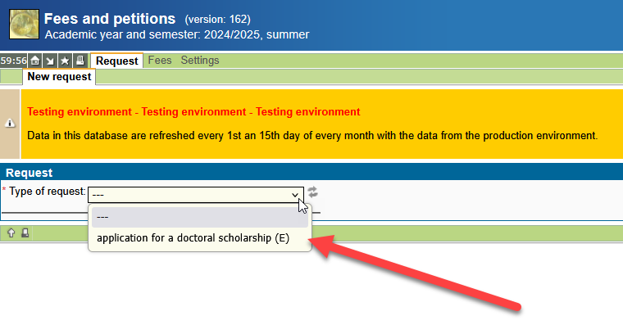

4. SELECT WHETHER OR NOT YOU HAVE INCOME FROM AN EMPLOYER IN THE GIVEN ACADEMIC YEAR THAT IS RELATED TO THE CREATION OF YOUR DISSERTATION.
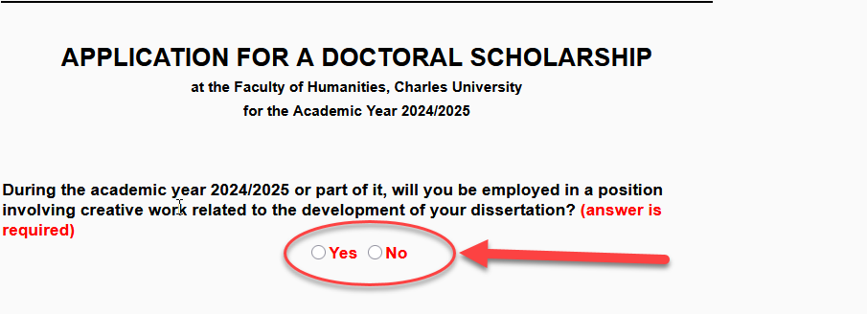

5. IF YES, FILL IN ALL REQUIRED FIELDS; IF NO, SKIP THIS SECTION.
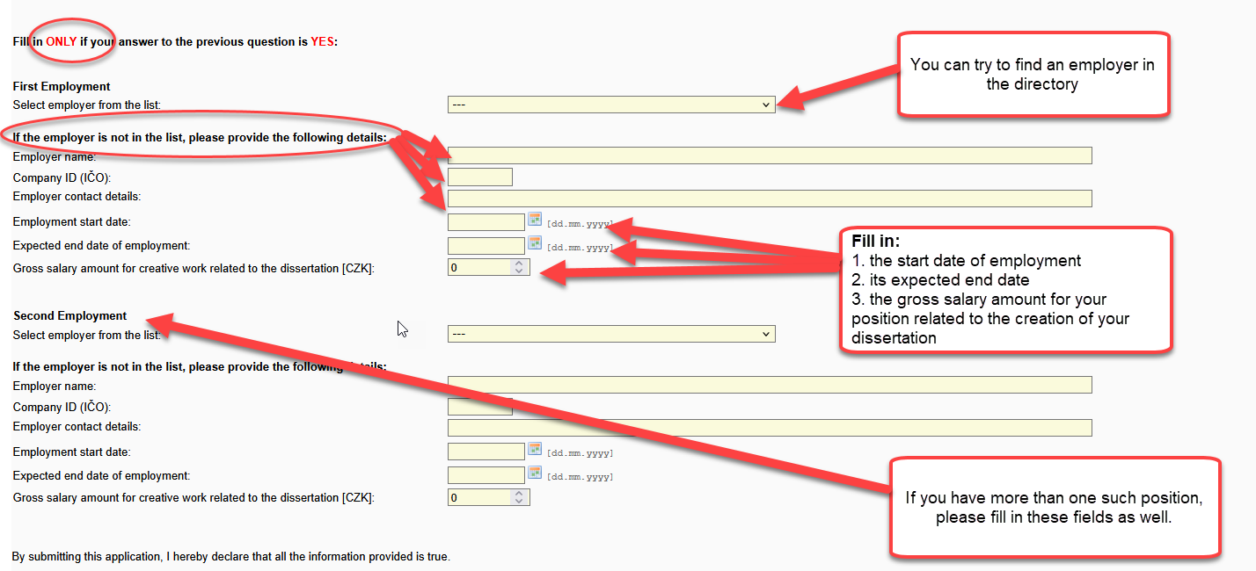

6. FINALLY, SUBMIT YOUR APPLICATION
